ABC Arms

HIGHLIGHT TEXT + INSERT PICTURE

HIGHLIGHT TEXT + INSERT PICTURE

? ?

HIGHLIGHT TEXT + INSERT PICTURE

HIGHLIGHT TEXT + INSERT PICTURE

? ?

ABC Arms

ORGANIZATION:

Time: 5-15 minutes

Set Up: Have students stand near their desks.

CURRICULUM: Math Common Core State Standards

Kindergarten
(Counting and Cardinality: K.CC.3)
Use your arms to write out numbers up to 20 in front of you.
First Grade
(Ops & Algebraic Thinking: 1.OA.5)
Use your arms to make a + sign, - sign, and =
sign to complete an equation.
● For example, 2+2=4, 2 (fingers up), + (arm addition sign) 2 (fingers up) = (equal sign) 4 (fingers up)

DIRECTIONS:

1. Stand up tall. Stand up proud.
2. Place your hands together.
3. Use your arms to write out the alphabet in front of you.

TEST STRESS:
Reach and Pull Breathing

1. Stand up tall. Stand up proud.
2. Breathe in through your nose (inhale) as you reach up.
3. Breathe out through your nose (exhale) as you pull your arms down.
4. Repeat several times.

Remember to record how long you exercised each day on your exercise log!

BLUE CARD 1

© 2013 New York Presbyterian Hospital

Marching

HIGHLIGHT TEXT + INSERT PICTURE

?

Marching

ORGANIZATION:

Time: 5-15 minutes

Set Up: Have students stand near their desks.

CURRICULUM: Math Common Core State Standards

Kindergarten
(Counting and Cardinality: K.CC.1)
Count up to 100 by 1s and 10s while
Marching.
First Grade
(Num. and Ops. in Base Ten: 1.NBT.1)
Count up to 120 while Marching.

DIRECTIONS:

1. Stand up tall. Stand up proud.
2. March in place.

TEST STRESS:
Find Your Pulse

1. Stand up tall. Stand up proud.
2. Before exercising, place two fingers on the back of your jaw bone.
3. Gently slide them down to the middle part of your neck, closer to your chin.
4. Feel your pulse.
5. Exercise for at least one minute.
6. Feel your pulse again to see if you feel a difference.

Remember to record how long you exercised each day on your exercise log!

BLUE CARD 2

© 2013 New York Presbyterian Hospital

Jumping Jacks

HIGHLIGHT TEXT + INSERT PICTURE

HIGHLIGHT TEXT + INSERT PICTURE

? ?

Jumping Jacks

ORGANIZATION:

Time: 5-15 minutes

Set Up: Have students stand near their desks.

CURRICULUM: Math Common Core State Standards

Kindergarten
(Ops. & Algebraic Thinking: K.OA.1)
While doing addition or subtraction, show the answer in Jumping Jacks.
● For example, 10-6=4. Do 4 jumping jacks.
First Grade
(Num. and Ops. in Base Ten: 1.NBT.1)
While doing addition or subtraction, show the answer in Jumping Jacks.
● For example, 20-7=13. Do 13 jumping jacks.

DIRECTIONS:

1. Stand up tall. Stand up proud.
2. Clap you hands over your head and jump your feet apart (like a capital A).
3. Bring your hands down and bring your feet together (like an I).
4. Repeat several times.

TEST STRESS:
Fast and Slow Motion

1. Stand up tall. Stand up proud.
2. Start doing jumping jacks.
3. When you hear “slow,” do jumping jacks very slowly as if you were in slow motion.
4. When you hear “fast,” do jumping jacks very slowly as if you were being fast-forwarded.

Remember to record how long you exercised each day on your exercise log!

BLUE CARD 3

© 2013 New York Presbyterian Hospital

Squats

HIGHLIGHT TEXT + INSERT PICTURE

HIGHLIGHT TEXT + INSERT PICTURE

? ?

Squats

ORGANIZATION:

Time: 5-15 minutes

Set Up: Have students stand near their desks.

CURRICULUM: Math Common Core State Standards

Kindergarten
(Measurement and Data: K.MD.2)
Compare the height of someone who is standing and someone who is squatting.
First Grade
(Measurement and Data: 1.MD.1)
Place in order from tallest to shortest of someone squatting, someone standing, and someone sitting in their seat.
● Compare the heights of each.

DIRECTIONS:
1. Stand up tall. Stand up proud.
2. Put your hands on your hips.
3. Bend your knees as if you are sitting in a chair without really sitting.
4. Stand up tall. Repeat several times.

TEST STRESS:
Bunny Breathing

1. Stand up tall. Stand up proud.
2. Take three quick breaths in through your nose (inhale).
3. Only let out three breaths out through your nose (exhale).
4. Repeat several times.

Remember to record how long you exercised each day on your exercise log!

BLUE CARD 4

© 2013 New York Presbyterian Hospital

Growing Tree Pose

HIGHLIGHT TEXT + INSERT PICTURE

?

Growing Tree Pose

ORGANIZATION:

Time: 5-15 minutes

Set Up: Have students stand near their desks.

CURRICULUM: Science Scope and Sequence

Kindergarten
(Unit 1: Trees Through the Season)
Create different Tree Poses seen during the seasons.
● In winter, you are a small seed.
● In spring, you are a growing tree.
● In summer, you are a strong tree.
● In fall, your leaves fall to the ground.

DIRECTIONS:
1. Stand up tall. Stand up proud.
First Grade
(Unit 3: Weather and Seasons)
Show how plants change with different seasons or weather with Tree Poses.
● In winter, you are a small seed.
● In spring, you are a growing tree.
● In summer, you are a strong tree.
● In fall, your leaves fall to the ground.

2. Focus your eyes on something that does not move.
3. Lift your arms overhead.
4. Lift one heel up with your toes still resting on the ground.
5. Repeat on the other side.

TEST STRESS:

Calm Mind, Calm Body

1. Stand up tall. Stand up proud.
2. Close your eyes and take several breaths.
3. Place the palms of your hands together and rub them together.
4. Build up some warmth and heat, and place your hands over your closed eyes.
5. Focus on the warm feeling and on something that makes you feel good.
6. Relax your mind. Relax your body.

Remember to record how long you exercised each day on your exercise log!

YELLOW CARD 1

© 2013 New York Presbyterian Hospital

Star Pose

HIGHLIGHT TEXT + INSERT PICTURE

?

Star Pose

ORGANIZATION:

Time: 5-15 minutes

Set Up: Have students stand near their desks.

CURRICULUM: Science Scope and Sequence

Kindergarten
(Unit 2: Exploring Properties)
Use your body to make different Star Poses.
● Shooting star: Stretch your arms and legs
out. Lean to one side and switch.
● Twinkling star: Stretch your arms and legs out. Wiggle your fingers.
First Grade
(Unit 2: Properties of Matter)
Use a tape measure or ruler to measure a partner’s Star Pose from one hand to the other.

DIRECTIONS:
1. Stand up tall. Stand up proud.
2. Spread out your arms and legs as if you were a star.

TEST STRESS:
Five Finger Breathing

1. Stand up tall. Stand up proud.
2. Hold up five fingers.
3. Breathe in through your nose (inhale) while counting slowly on your five fingers.
4. Breathe out through your nose (exhale) while counting slowly on your five fingers.
5. Repeat several times.

Remember to record how long you exercised each day on your exercise log!

YELLOW CARD 2

© 2013 New York Presbyterian Hospital

Wood Chop Pose

HIGHLIGHT TEXT + INSERT PICTURE

HIGHLIGHT TEXT + INSERT PICTURE

? ?

Wood Chop Pose

ORGANIZATION:

Time: 5-15 minutes

Set Up: Have students stand near their desks.

CURRICULUM: Science Scope and Sequence

Kindergarten
(Unit 2: Exploring Properties)
Use your Wood Chop Pose to cut down the tree.
● What is a tree made of?

DIRECTIONS:
First Grade
(Unit 3: Weather and Seasons)
The sun moves from east to west.
● Place both hands to the right. This
represents the sun rising from the “east.”
● Slowly bring one hand towards the left.
This represents the positions of the sun during the day and setting in the “west.”

1. Turn in the chair to have open space in front of you.
2. Place your hands together over your head.
3. Slowly bring your hands down towards the floor.
4. Slowly bring your hands up towards the ceiling.
5. Repeat several times.

TEST STRESS:

Positive Thinking

1. Stand up tall. Stand up proud.
2. Close your eyes and take several deep breaths.
3. Focus on a positive thought or good feeling while relaxing your mind and body.
4. Focus on this positive thought for 30 seconds, or until you feel calm.

Remember to record how long you exercised each day on your exercise log!

YELLOW CARD 3

© 2013 New York Presbyterian Hospital

Child’s Pose

HIGHLIGHT TEXT + INSERT PICTURE

?

Child’s Pose

ORGANIZATION:

Time: 5-15 minutes

Set Up: Have students stand near their desks.

CURRICULUM: Science Scope and Sequence

Kindergarten
(Unit 3: Animals)
Some animals, such as bears, squirrels, and bats, hibernate, or take a deep sleep, during the winter.
● When you hear the word, hibernate, go into
Child’s Pose.
● Bats hibernate in caves.
● Bears hibernate in dens.

DIRECTIONS:
1. Sit up tall. Sit up proud.
First Grade
(Unit 1: Animal Diversity)
Bears hibernate in dens. Bats hibernate in caves. When you hear the correct match, place your head down on your desk as with Child’s Pose.

2. Lift your hands up and let them greatly fall towards your desk.
3. Look down at your toes and gently lean back.
4. Hold for several seconds.

TEST STRESS:
Tense and Relax

1. Sit up tall. Sit up proud.
2. Choose one body part that you will tense or squeeze.
3. Hold that squeeze for a few seconds and then relax.
4. Now tense and relax other parts of your body.

Remember to record how long you exercised each day on your exercise log!

YELLOW CARD 4

© 2013 New York Presbyterian Hospital

Arm Circles

HIGHLIGHT TEXT + INSERT PICTURE

HIGHLIGHT TEXT + INSERT PICTURE

? ?

Arm Circles

ORGANIZATION:

Time: 5-15 minutes

Set Up: Have students stand near their desks.

CURRICULUM: Math Common Core State Standards

Second Grade
(Num. & Ops. in Base Ten: 2.NBT.4)
When comparing two numbers, make a < sign or > sign with your arms.
● < sign: extend your open arms out in front
of you and turn them to the right.
● > sign: extend your open arms out in front
of you and turn them to the left.

DIRECTIONS:

1. Stand up tall. Stand up proud.
2. Make circles with your entire arm.
Third Grade
(Measurment and Data: 3.MD.1)
Use your arms to tell time.
● Your left arm tells the hours.
● Your right arm tells the minutes.
● For example, use your arms to tell 3:15

TEST STRESS:
Reach and Pull

1. Stand up tall. Stand up proud.
2. Breathe in through your nose (inhale) as you reach up.
3. Breathe out through your nose (exhale) as you pull your arms down.
4. Repeat several times.

Remember to record how long you exercised each day on your exercise log!

BLUE CARD 1

© 2013 New York Presbyterian Hospital

Running in Place

HIGHLIGHT TEXT + INSERT PICTURE

?

Running in Place

ORGANIZATION:

Time: 5-15 minutes

Set Up: Have students stand near their desks.

CURRICULUM: Math Common Core State Standards

Second Grade
(Ops. & Algebraic Thinking: 2.OA.2)
While doing addition or subtraction, tell the answer while Running in Place.
● For example, 25-5=20. Run for 20 seconds
or steps.
Third Grade
(Measurment and Data: 3.MD.8)
While solving for perimeter, Run in Place for each given side and the total length.
● For example, for a rectangle with a perimeter of 3 x 2, run for 3 steps for each long side and 2 steps for each short side.

DIRECTIONS:

1. Stand up tall. Stand up proud.
2. Run in place.

TEST STRESS: Find Your Pulse
1. Stand up tall. Stand up proud.
2. Before exercising, place two fingers on the back of your jaw bone.
3. Gently slide down to the middle part of your neck, closer to your chin.
4. Feel for your pulse.
5. Exercise for at least one minute.
6. Feel for your pulse again to see if you feel a difference.

Remember to record how long you exercised each day on your exercise log!

BLUE CARD 2

© 2013 New York Presbyterian Hospital

Skipping

HIGHLIGHT TEXT + INSERT PICTURE

?

Skipping

ORGANIZATION:

Time: 5-15 minutes

Set Up: Have students stand near their desks.

CURRICULUM: Math Common Core State Standards

Second Grade
(Num. & Ops. in Base Ten: 2.NBT.2)
When counting up to 1000, Skip while counting by 5s, 10s, 100s.
Third Grade
(Num. & Ops. in Base Ten: 3.NBT.3)
While Multiplying or dividing, Skip out the answer.
● For example, 2 x 20 = 40. Do 40 skips.

DIRECTIONS:
1. Stand up tall. Stand up proud.
2. Bring your knees up, as with marching.
3. Push off your toes as you add a little hop to each march. Lift your arm up.
4. Land flat on your foot.
5. Repeat several times.

TEST STRESS:

Fast and Slow Motion

1. Stand up tall. Stand up proud.
2. Start skipping in place.
3. When you hear “slow,” skip very slowly as if you were in slow motion.
4. When you hear “fast,” skip very quick;y as if you were being fast-forwarded.

Remember to record how long you exercised each day on your exercise log!

BLUE CARD 3

© 2013 New York Presbyterian Hospital

Squats

HIGHLIGHT TEXT + INSERT PICTURE

HIGHLIGHT TEXT + INSERT PICTURE

? ?

Squats

ORGANIZATION:

Time: 5-15 minutes

Set Up: Have students stand near their desks.

CURRICULUM: Math Common Core State Standards

Second Grade
(Ops. & Algebraic Thinking: 2.OA.3)
When counting:
● Every time you hear an odd number stand
up.
● Every time you hear an ever number Squat
down.

DIRECTIONS:
1. Stand up tall. Stand up proud.
2. Put your hands on your hips.
Third Grade
(Num. & Operation-Fravtions: 3.NF.1)
A fraction has a numerator (top number) and a denominator (bottom number).
● Every time you say or hear the numerator,
stand up.
● Every time you say or hear the
denominator, Squat down.

3. Bend your knees as if you are sitting in a chair without really sitting.
4. Stand up tall.
5. Repeat several times.

TEST STRESS:
Bunny Breathing

1. Stand up tall. Stand up proud.
2. Take three quick breaths in through your nose (inhale).
3. Only let our one breath through your nose (exhale).
4. Repeat several times.

Remember to record how long you exercised each day on your exercise log!

BLUE CARD 4

© 2013 New York Presbyterian Hospital

Tree Pose

HIGHLIGHT TEXT + INSERT PICTURE

?

Tree Pose

ORGANIZATION:

Time: 5-15 minutes

Set Up: Have students stand near their desks.

CURRICULUM: Science Scope and Sequence

Second Grade
(Unit 3: Plant Diversity)
When in Tree Pose, identify the different parts of a tree.
Third Grade
(Unit 4: Plant and Animal Adaptations)
When in Tree Pose, you or a partner identify the different parts of a tree.
● What do those parts do?
● How do they help the tree survive?

DIRECTIONS:
1. Stand up tall. Stand up proud.
2. Focus your eyes on something that does not move.
3. Lift your arms overhead.
4. Lift one foot up and let it rest on the other leg.
5. Repeat on the other side.

TEST STRESS:

Calm Mind, Calm Body

1. Stand up tall. Stand up proud.
2. Close your eyes and take several deep breaths.
3. Place the palms of your hands together and rub them together.
4. Build up some warmth and heat, and place your hands over your closed eyes.
5. Focus on the warm feeling and on something that makes you feel good.
6. Relax your mind. Relax your body.

Remember to record how long you exercised each day on your exercise log!

YELLOW CARD 1

© 2013 New York Presbyterian Hospital

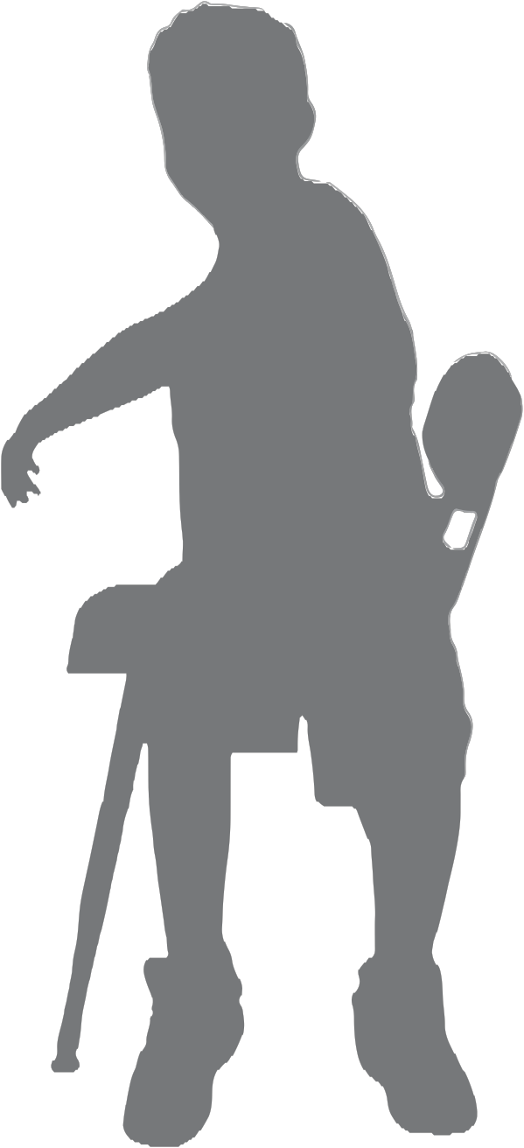
Seated Twist Pose

HIGHLIGHT TEXT + INSERT PICTURE

HIGHLIGHT TEXT + INSERT PICTURE

? ?

Seated Twist Pose

ORGANIZATION:

Time: 5-15 minutes

Set Up: Have students stand near their desks.

CURRICULUM: Science Scope and Sequence

Second Grade
(Unit 2: Forces and Motion)
Try twisting quickly and slowly.
● When you are twisting, you are pushing your
hand down to your leg.
● When you are untwisting, you are pulling
your hand away from your leg.
Third Grade
(Unit 3: Simple Machines)
Try twisting quickly and slowly.
● How would your speed change if you had something heavy in your hands?
● How would your speed change if you had something light in your hands?

DIRECTIONS:
1. Stand up tall. Stand up proud.
2. Reach your right hand in the air.
3. Bring it across your body, toward your opposite hip or leg.
4. Twist your body to look behind you.
5. Repeat on the other side.
TEST STRESS: Five Finger Breathing
1. Sit up tall. Sit up proud.
2. Hold up five fingers.
3. Breathe in through your nose (inhale) while counting slowly on your five fingers.
4. Breathe out through your nose (exhale) while counting slowly on your five fingers.
5. Repeat several times.

Remember to record how long you exercised each day on your exercise log!

YELLOW CARD 2

© 2013 New York Presbyterian Hospital

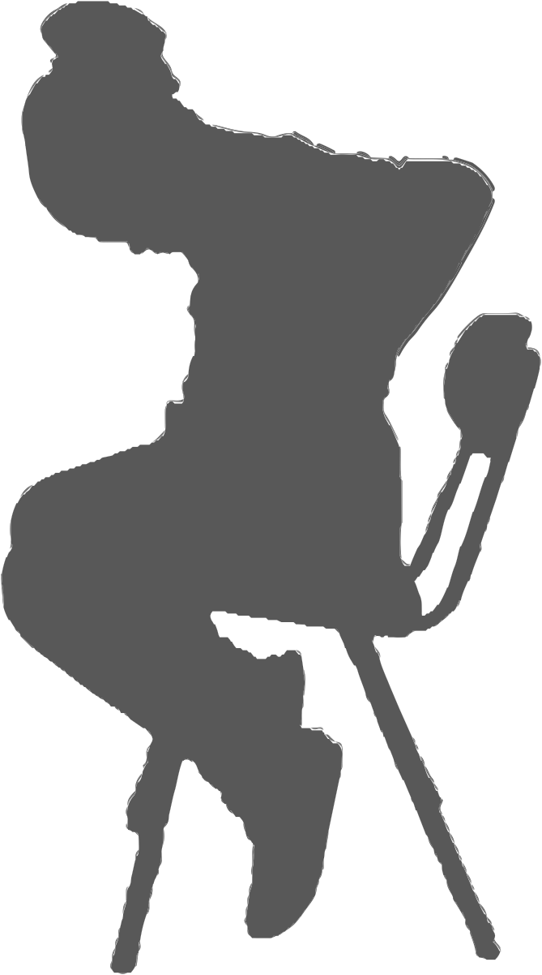
Camel Pose

HIGHLIGHT TEXT + INSERT PICTURE

HIGHLIGHT TEXT + INSERT PICTURE

? ?

Camel Pose

ORGANIZATION:

Time: 5-15 minutes

Set Up: Have students stand near their desks.

CURRICULUM: Science Scope and Sequence

Second Grade
(Unit 2: Forces and Motion)
Observe and compare the differences in the body when in Camel Pose and when seated.
Third Grade
(Unit 4: Plant and Animal Adaptations)
A camel can survive in the desert because of its hump, an adaptation.
● Learn more about animal adaptatons.
● Create new poses to show these animals
or adaptations.

DIRECTIONS:
1. Sit up tall. Sit up proud.
2. Place your hand on your lower back with your elbows back.
3. Slowly lift your chin high towards the ceiling as you open up your chest.
4. Slowly tuck your chin back into your chest as you round your back.

TEST STRESS: Positive Thinking

1. Sit up tall. Sit up proud.
2. Close your eyes and take several deep breaths.
3. Focus on a positive thought or good feeling while relaxing your mind and body.
4. Focus on this positive thought for 30 seconds, or until you feel calm.

Remember to record how long you exercised each day on your exercise log!

YELLOW CARD 3

© 2013 New York Presbyterian Hospital

Child’s Pose

HIGHLIGHT TEXT + INSERT PICTURE

?

Child’s Pose

ORGANIZATION:

Time: 5-15 minutes

Set Up: Have students stand near their desks.

CURRICULUM: Science Scope and Sequence

Second Grade
(Unit 2: Forces and Motion)
Observe and compare the differences in the body when in Child’s Pose and when seated.
Third Grade
(Unit 3: Simple Machines)
How would Child’s Pose look if there was no
gravity?

DIRECTIONS:
1. Sit up tall. Sit up proud.
2. Lift your hands up and let them gently fall towards your desk.
3. Look down at your toes and gently lean back.
4. Hold for several seconds.

TEST STRESS:

1. Sit up tall. Sit up proud.
Tense and Relax

2. Choose one body part that you will tense or squeeze.
3. Hold that squeeze for a few seconds and then relax.
4. Now tense and relax other parts of your body.

Remember to record how long you exercised each day on your exercise log!

YELLOW CARD 4

© 2013 New York Presbyterian Hospital

Liberty Lifts

HIGHLIGHT TEXT + INSERT PICTURE

HIGHLIGHT TEXT + INSERT PICTURE

? ?

Liberty Lifts

ORGANIZATION:

Time: 5-15 minutes

Set Up: Have students stand near their desks.

CURRICULUM: Math Common Core State Standards

Fourth Grade
(Geometry: 4.G.1)
Use your arms to make angles.
● Acute angle: stretch your right arm out to the side. Raise your left arm straight, but leaning toward your right arm.
● Obtuse angle: stretch your right arm out to the side. Raise your left arm up but leaning away from your right arm.
DIRECTIONS:
1. Stand up tall. Stand up proud.
2. Raise one arm up.
Fifth Grade
(Num. & Ops. in Base Ten: 5.NBT.3.B)
When comparing two decimals, make a <
sign or > sign with your arms.
● < sign: extend your open arms out in front
of you and turn them to the right.
● > sign: extend your open arms out in front
of you and turn them to the left.

3. Bring it across your body, towards your hip or opposite leg.
4. Raise it back up.
5. Repeat several times and then switch sides.

TEST STRESS:

Reach and Pull Breathing

1. Stand up tall. Stand up proud.
2. Breathe in through your nose (inhale) as you reach up.
3. Breath out through your nose (exhale) as you pull your arms down.
4. Repeat several times.

Remember to record how long you exercised each day on your exercise log!

BLUE CARD 1

© 2013 New York Presbyterian Hospital

Cross Countries

HIGHLIGHT TEXT + INSERT PICTURE

?

Cross Countries

ORGANIZATION:

Time: 5-15 minutes

Set Up: Have students stand near their desks.

CURRICULUM: Math Common Core State Standards

Fourth Grade
(Ops. & Algebraic Thinking: 4.OA.5)
Create a number pattern by acting out each new rule with Cross Countries.
● For example if the rule is “Add 3,” then you must do three cross countries before stating the next number in the pattern.
Fifth Grade
(Measurement & Data: 5.MD.1)
When converting meters (m) into centimeters
(cm) each answer should be given with
Cross Countries.
● For example, in 0.25 m there are 25 cm.
Do 25 cross countries.

DIRECTIONS:
1. Stand up tall. Stand up proud.
2. Reach one arm forward and step one leg forward.
3. Quickly switch to bring your other arm and leg forward.
4. Repeat several times.

TEST STRESS:
Find Your Pulse

1. Stand up tall. Stand up proud.
2. Before exercising, place two fingers on the back of your jaw bone.
3. Gently slide them down to the middle part of your neck, closer to your chin.
4. Feel for your pulse.
5. Exercise for at least one minute.
6. Feel for your pulse again to see if you feel a difference.

Remember to record how long you exercised each day on your exercise log!

BLUE CARD 2

© 2013 New York Presbyterian Hospital

Jumping Jacks

HIGHLIGHT TEXT + INSERT PICTURE

HIGHLIGHT TEXT + INSERT PICTURE

? ?

Jumping Jacks

ORGANIZATION:

Time: 5-15 minutes

Set Up: Have students stand near their desks.

CURRICULUM: Math Common Core State Standards

Fourth Grade
(Num. & Ops. in Base Ten: 4.NBT.1)
While doing multiplication or division, show the answer in Jumping Jacks.
● For example, 4x10=40. Do 40 jumping jacks.
Fifth Grade
(Num. & Ops. in Base Ten: 5.NBT.2)
While doing multiplication or division with decimals, show the answer in Jumping Jacks.
● For example, 60 x 0.3= 18. Do 18 jumping jacks.

DIRECTIONS:
1. Stand up tall. Stand up proud.
2. Clap your hands over your head and jump your feet apart (like a capital A).
3. Bring your hands down and bring your feet together (like and I).
4. Repeat several times.

TEST STRESS:
Fast and Slow Motion

1. Stand up tall. Stand up proud.
2. Start doing jumping jacks.
3. When your hear “slow,” do jumping jacks very slowly as if you were in slow motion.
4. When your hear “fast,” do jumping jacks very quickly as if you were being fast-forwarded.

Remember to record how long you exercised each day on your exercise log!

BLUE CARD 3

© 2013 New York Presbyterian Hospital

Squats

HIGHLIGHT TEXT + INSERT PICTURE

HIGHLIGHT TEXT + INSERT PICTURE

? ?

Squats

ORGANIZATION:

Time: 5-15 minutes

Set Up: Have students stand near their desks.

CURRICULUM: Math Common Core State Standards

Fourth Grade
(Ops. & Algebraic Thinking: 4.OA.4)
Determine if a given whole number is prime or
composite.
● If the whole number is prime, then stand up.
● If the whole number is a composite, then
Squat down.
Fifth Grade
(Geometry: 5.G)
Determine if a line is parallel or perpendicular to an axis.
● If the line is parallel, then stand up.
● If the line is perpendicular, then Squat down.

DIRECTIONS:
1. Stand up tall. Stand up proud.
2. Put your hands on your hips.
3. Bend your knees as if you are sitting in a chair without really sitting.
4. Stand up tall.
5. Repeat several times.

TEST STRESS:

Dragon Breathing

1. Stand up tall. Stand up proud.
2. Take quick breaths in through your nose (inhale).
3. Take quick breaths out through your nose (exhale).
4. Repeat several times.

Remember to record how long you exercised each day on your exercise log!

BLUE CARD 4

© 2013 New York Presbyterian Hospital

Eagle-Tree Pose

HIGHLIGHT TEXT + INSERT PICTURE

?

Eagle-Tree Pose

ORGANIZATION:

Time: 5-15 minutes

Set Up: Have students stand near their desks.

CURRICULUM: Science Scope and Sequence

Fourth Grade
(Unit 1: Animals & Plants Environment)
While in Eagle-Tree Pose identify the different parts of an eagle and a tree.
● How do trees get food, air, and water?
● How do eagles get food, air, and water?
Fifth Grade
(Unit 4: Exploring Ecosystems)
A forest is made up of many different types of plants.
● Create a pose for these different types of
plants and tress that make up a forest.

DIRECTIONS:
1. Stand up tall. Stand up proud.
2. Focus your eyes on something that does not move.
3. Cross one arm over another with your hands on your chest.
4. Slowly slide one foot up against the other leg.
5. Repeat on the other side.

TEST STRESS:

Calm Mind, Calm Body

1. Stand up tall. Stand up proud.
2. Close your eyes and take several deep breaths.
3. Place the palms of youe hands together and rub them together.
4. Build up some warmth and heat, and place your hands over your closed eyes.
5. Focus on the warm feeling and on something that makes you feel good.
6. Relax your mind. Relax your body.

Remember to record how long you exercised each day on your exercise log!

YELLOW CARD 1

© 2013 New York Presbyterian Hospital

Warrior 1 Pose

HIGHLIGHT TEXT + INSERT PICTURE

?

Warrior 1 Pose

ORGANIZATION:

Time: 5-15 minutes

Set Up: Have students stand near their desks.

CURRICULUM: Science Scope and Sequence

Fourth Grade
(Unit 1: Animals & Plants Environment)
During ancient times, people had different
roles in the community.
● Create a new pose for warriors, hunters,
gatherers, farmers, and merchants.
Fifth Grade
(Unit 3: Food and Nutrition)
During ancient times, people had different
roles in a community.
● Create new poses for the different people
responsible for a community’s food supply.
● How have these roles changed?

DIRECTIONS:

1. Sit up tall. Sit up proud.
2. Bend on knee while keeping the other leg straight.
3. Turn your body in the same directions as your bent knee.
4. Reach your hands up high in the air.
5. Repeat on the other side.

TEST STRESS:

Five Finger Breathing

1. Sit up tall. Sit up proud.
2. Hold up five fingers.
3. Breathe in through your nose (inhale) while slowly counting to five on your finger.
4. Breathe out through your nose (exhale) while slowly counting to five on your fingers.
5. Repeat several times.

Remember to record how long you exercised each day on your exercise log!

YELLOW CARD 2

© 2013 New York Presbyterian Hospital

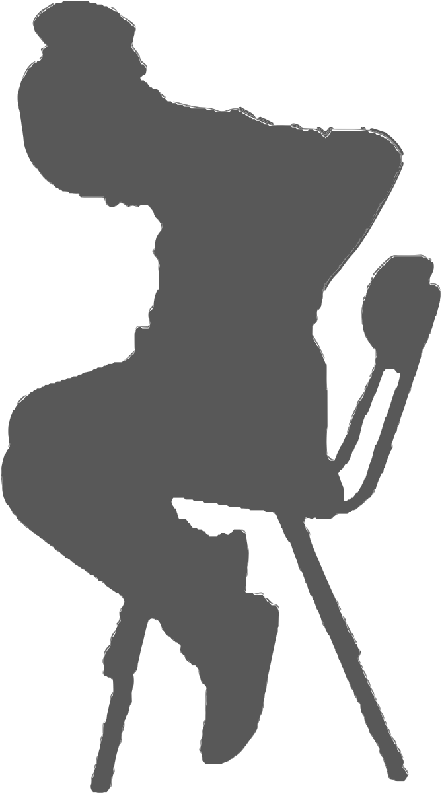
Camel Pose

HIGHLIGHT TEXT + INSERT PICTURE

HIGHLIGHT TEXT + INSERT PICTURE

? ?

Camel Pose

ORGANIZATION:

Time: 5-15 minutes

Set Up: Have students stand near their desks.

CURRICULUM: Science Scope and Sequence

Fourth Grade
(Unit 1: Animals & Plants Environment)
People sometimes use camels to travel across the desert.
● Create a pose of an animal that would help
you travel to school.
● How does that animal fit into your environment?

DIRECTIONS:
1. Sit up tall. Sit up proud.
Fifth Grade
(Unit 4: Exploring Ecosystems)
People sometimes use camels to travel across the desert.
● What adaptations make the camel a good choice for desert travel?
● Create a pose of an animal that would help you travel to school. Describe it.

2. Place your hand on your lower back with your elbows back.
3. Slowly lift your chin high towards the ceiling as you open up your chest.
4. Slowly tuck your chin back into your chest as you round your back.

TEST STRESS:

1. Sit up tall. Sit up proud.
Positive Thinking

2. Close your eyes and take several deep breaths.
3. Focus on a positive thought or good feeling while relaxing your mind and body.
4. Focus on a positive thought for 30 seconds, or until you feel calm.

Remember to record how long you exercised each day on your exercise log!

YELLOW CARD 3

© 2013 New York Presbyterian Hospital

Child’s Pose

HIGHLIGHT TEXT + INSERT PICTURE

?

Child’s Pose

ORGANIZATION:

Time: 5-15 minutes

Set Up: Have students stand near their desks.

CURRICULUM: Science Scope and Sequence

Fourth Grade
(Unit 1: Animals & Plants Environment)
People and animals need to sleep to survive.
● Why is it important to get a good night’s sleep?
● While discussing sleep, place your head
down as with Child’s Pose.
Fifth Grade
(Unit 1: Animals & Plants Environment)
People and animals need to sleep to survive.
● Why is it important to get a good night’s sleep?
● While discussing sleep, place your head
down as with Child’s Pose.

DIRECTIONS:
1. Sit up tall. Sit up proud.
2. Lift your hands up and let them gently fall towards your desk.
3. Look down at your toes and gently lean back.
4. Hold for several seconds.

TEST STRESS:

1. Sit up tall. Sit up proud.
Tense and Relax

2. Choose one body part that you will tense or squeeze.
3. Hold that squeeze for a few seconds and then relax.
4. Now tense and relax other parts of your body.

Remember to record how long you exercised each day on your exercise log!

YELLOW CARD 4

© 2013 New York Presbyterian Hospital

